ECO System tutorial

Welcome to VCU’s ECO System! This system makes submitting export compliance requests simple, fast, and efficient. If you have a request for Travel, or a Visa approval please visit the Office of the Vice President for Research and Innovation’s Export Compliance website. The instructions for using the electronic system follow below.
Log in with your VCU ID and password.
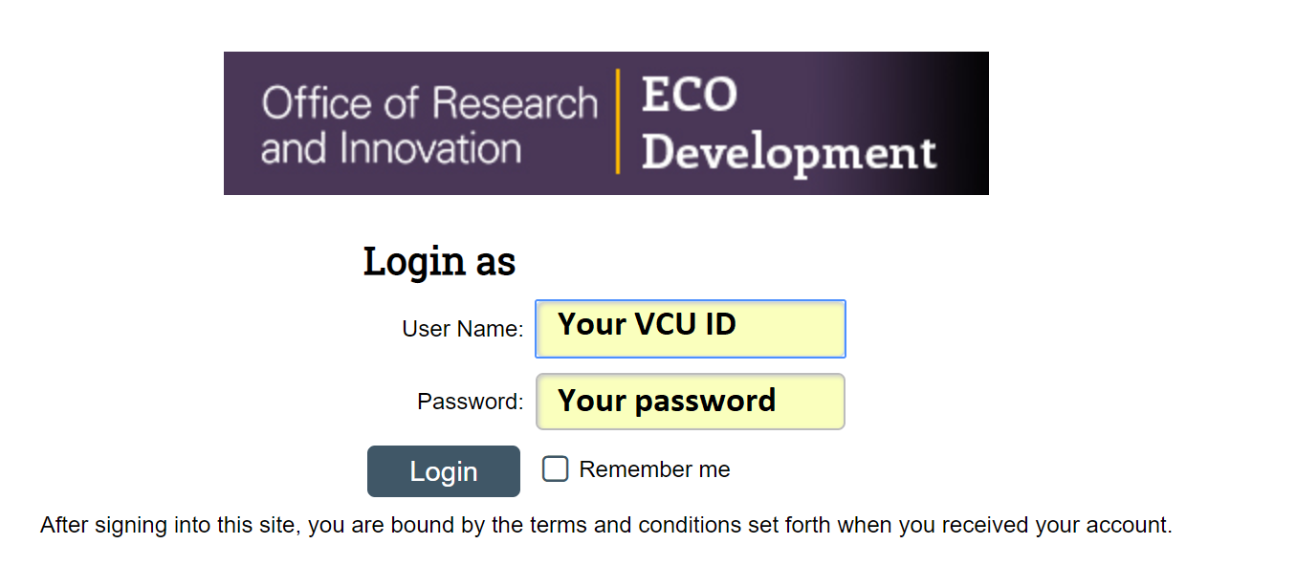
First you will see the Home screen. Select the Export Control tab towards the top of the screen.
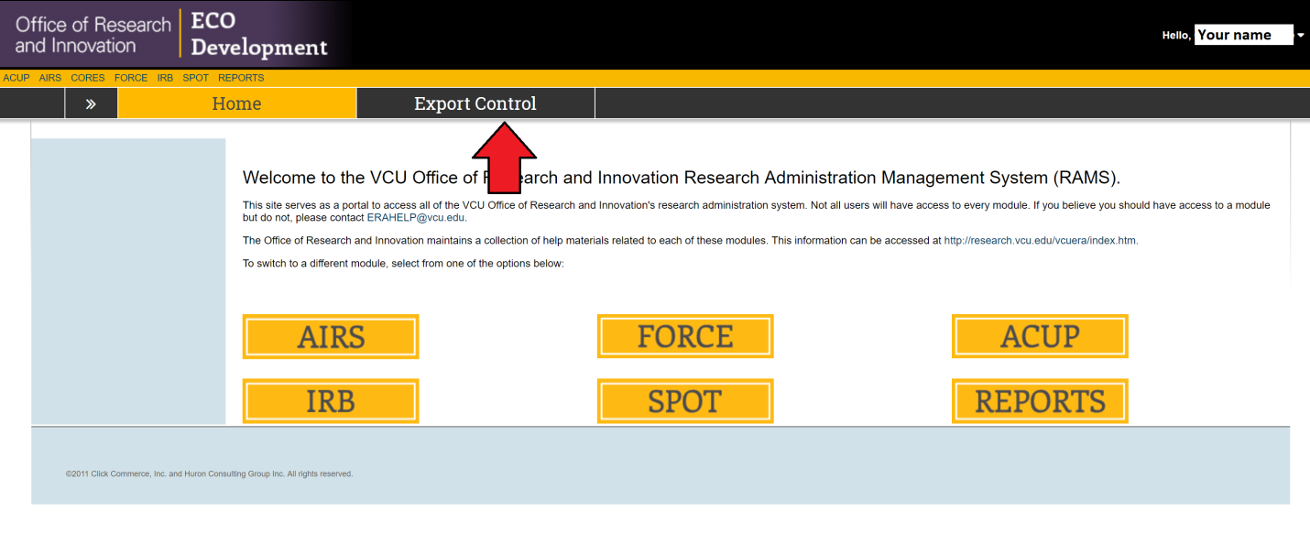
Next, to make a new review, select Create Review.
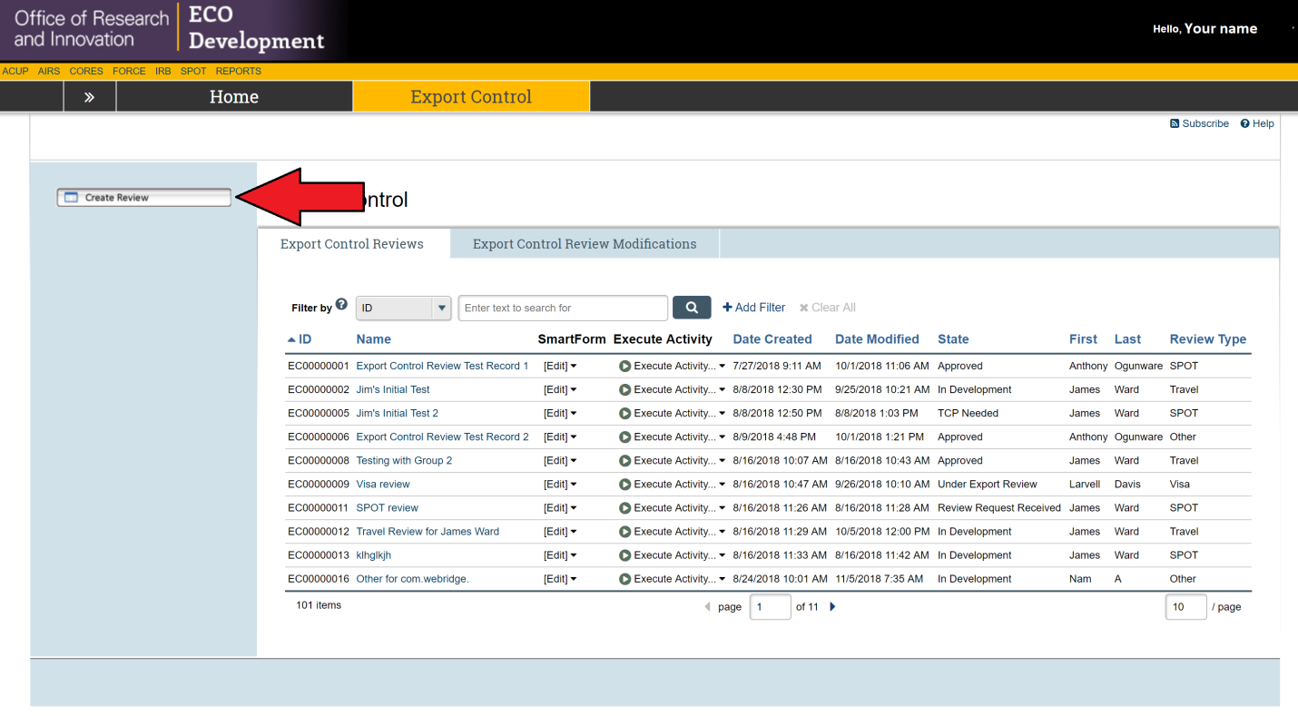
Now select the type of review that you will be submitting, either Travel or Visa. You will be asked for information based on the type of review. To see instructions for each type of review hold down the Ctrl key and click on the underlined word Travel or Visa in this sentence to be taken to the instructions for that type of review.

Travel requests

The first step once you have selected Travel is to type in the name of the person who will be traveling with the first name listed first in the box marked “name”. Next select the “Travel From” and “Travel To” dates by clicking on the grey calendar box and selecting a date. The “Travel From” is the date when the travel starts and “Travel To” is the date when the travel ends. Finally click on the grey box with three dots and select the country of destination for this trip and then select Continue at the bottom right.
For the second step select the items that the traveler will be bringing with them on the trip. You can select more than one but you have to select at least one. If you are taking nothing select “Other” and type “N/A” in the drop down-box. Some selections will open a drop-down box which will require you to list and describe all related items. When you are done click the Continue button.
For the third step click on one of the dots to select the purpose of your visit. You can either select Conference/Meeting, Research, or Other. A drop-down box will pop up for “Research” or “Other”. Please type an explanation of the purpose of your trip. If you select “Conference/Meeting” a second question will ask if it is open to the public. If it is not open to the public a drop-down box will open. Type an explanation of purpose the conference or meeting and give a web-link to the conference if there is one. Finally click the button to continue.

For the forth step list the persons and organizations that you will be interacting with as part of your trip. Click on the grey button marked “+ Add”. A box will open. In it type the name of a person and the organization that they are part of. Then click “OK” if you’re done or “Ok and Add Another” if there are more to add. When you’re done click the Continue button.
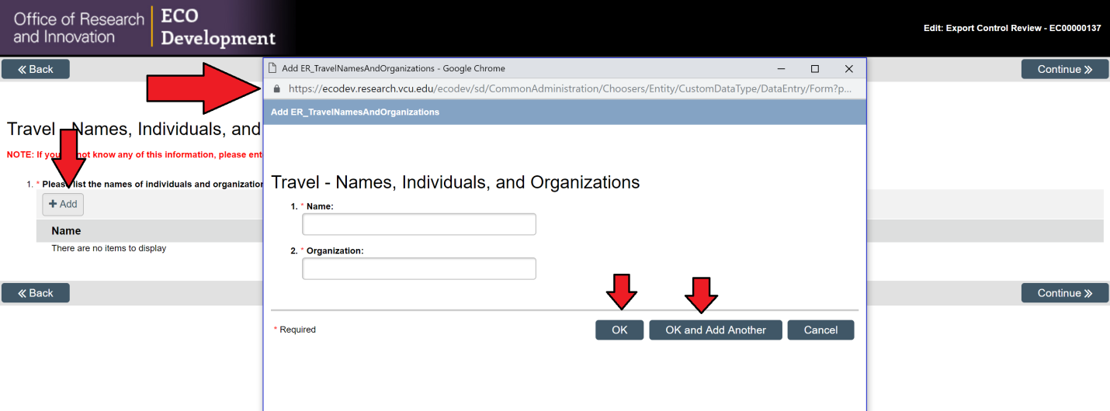

The fifth step involves adding documents related to your trip if any. Click on the grey button marked “+ Add”. A box will open where you can type the title of the document. Then click on the grey box marked “Choose File” and choose the file location from your computer to upload. Once that is done click “OK” if you are done or “OK and Add Another” if you have more to add. Some examples of travel related documents would be an itinerary, guest list, or flyer for the event. Then hit the Continue button.
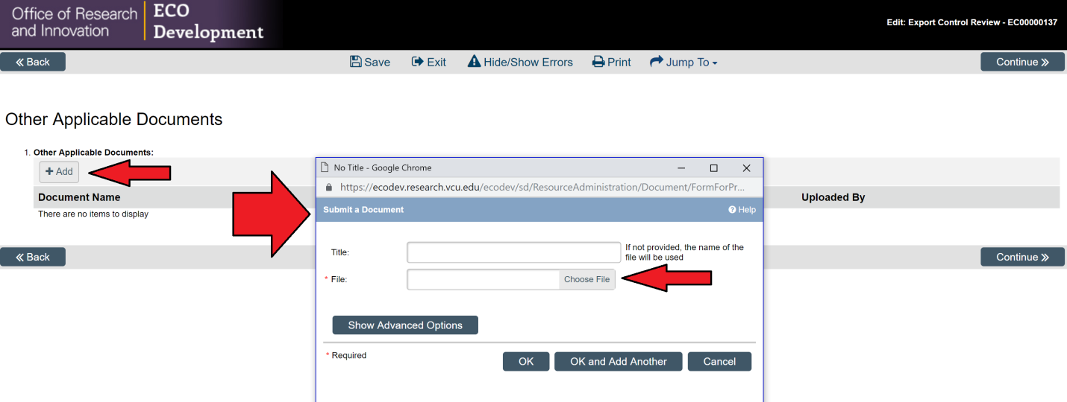
This will bring up the following screen. Select Finish.
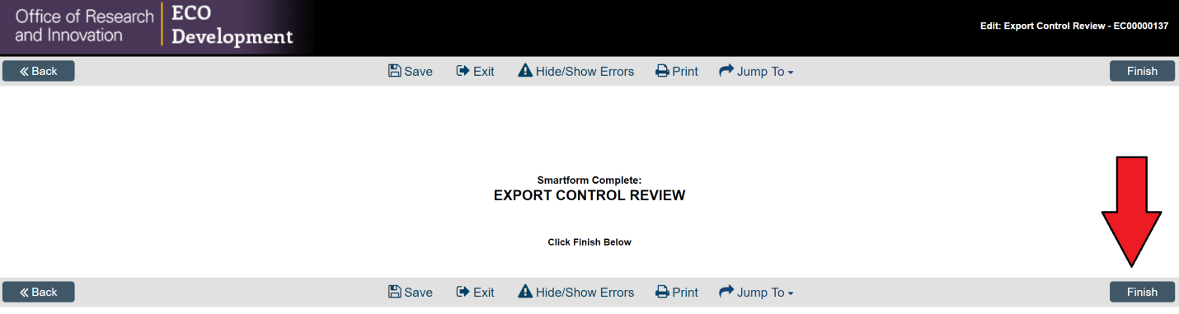
A screen will open up reminding you to click “Submit” under “My Activities” to submit the form. After clicking that a box will open which allows you to add additional comments if any. Click Ok and you are done.
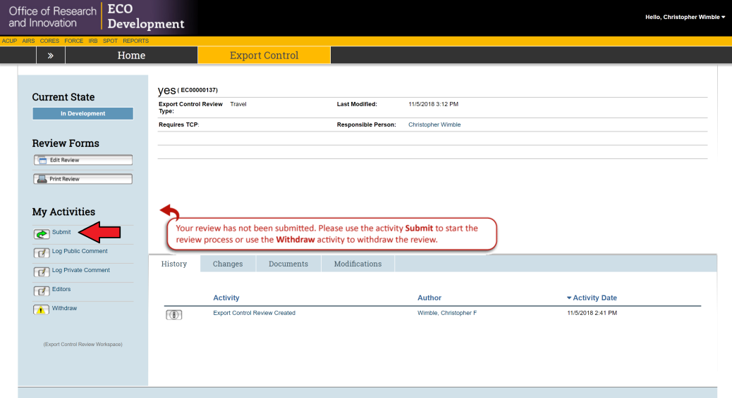

Visa approvals

After clicking on the circle for Visa select “Continue” at the bottom right and a new window will open. Under “Responsible Person” your name will appear though you can change that by clicking on the grey box with three dots. Under “Department/School” click on the grey box with the three dots and a box will open up that allows you to select from a list which you can scroll though using the arrows at the bottom of the new window or by entering the name in the search field and clicking “Go”. When you’ve selected your department hit the “OK” button at the bottom of the new box. Finally hit the “Continue” button at the bottom.
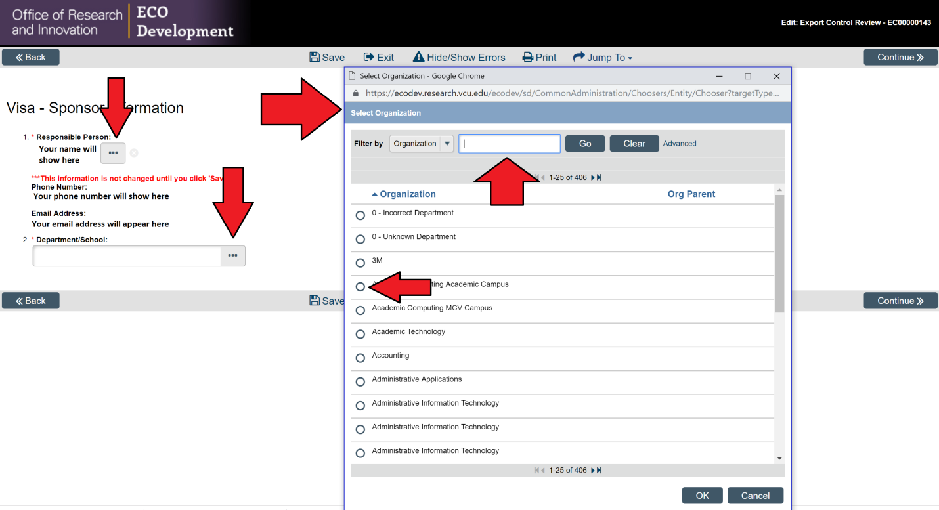

After hitting the Continue button a new screen will open. Type in the name of the beneficiary with the first name first. Then click on the grey box with three dots to open a new window to select the country or countries of citizenship for the beneficiary. Note you can select more than one if the person has more than one citizenship. Finally type the employer of the beneficiary or “N/A” if there is no foreign employer and click on the Continue button.

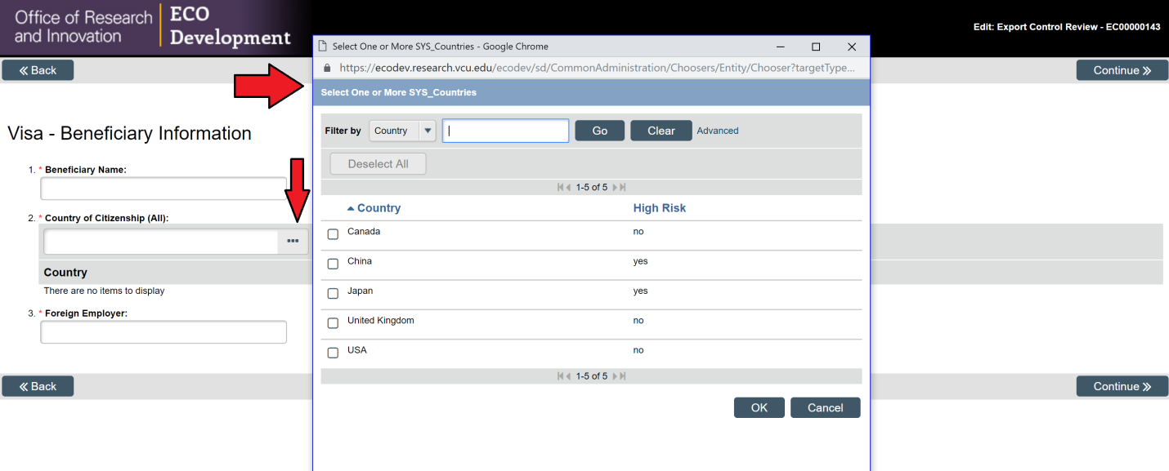

The next screen that will appear deals with general questions. In the box under question #1 list and detail all of the duties that the beneficiary will perform. Avoid being too general. Next answer the questions about what the person will have access to. In some cases this will open a box and when this happens please list and detail the materials or equipment that they will have access to. Finally select the Visa type and then hit the Continue button.
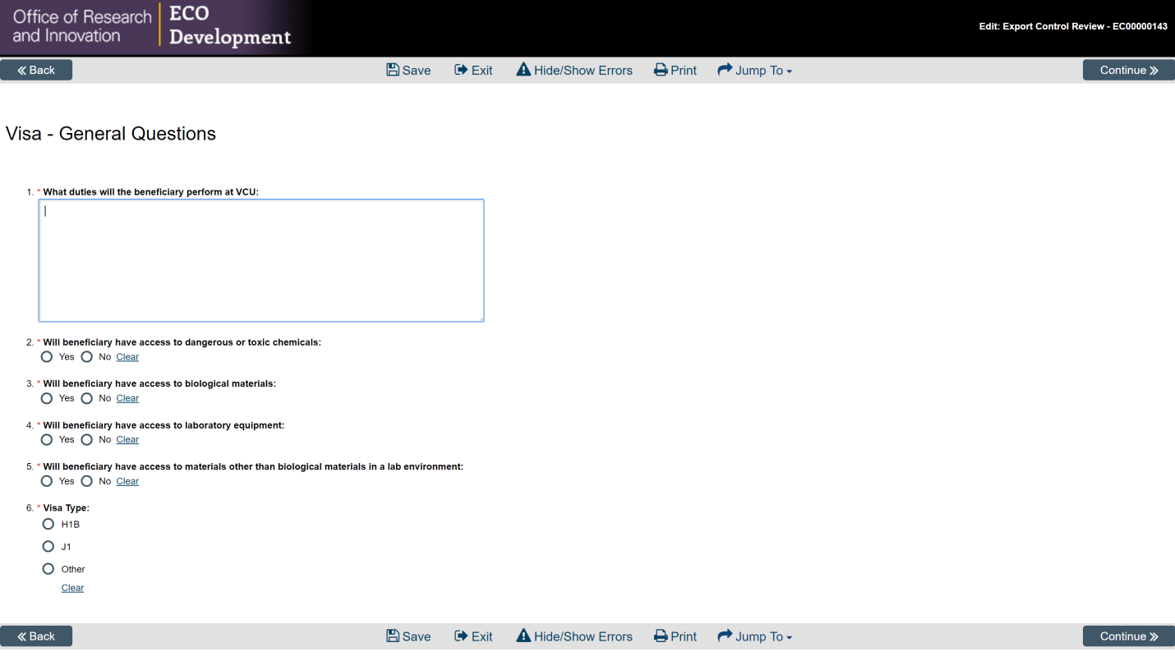

A screen will open asking if the beneficiary will participate in research. If so than other question will open. Once the questions have been answered hit the Continue button.
Next a screen will open allowing you to add related documents. Please add the Export Control Pre-Screening form as well as the Visiting Scholar Agreement if there is one. Click on the grey button marked “+ Add”. A box will open where you can type the title of the document. Then click on the grey box marked “Choose File” and choose the file location from your computer to upload. Once that is done click “OK” if you are done or “OK and Add Another” if you have more to add. Click the Continue button.
This will bring up the following screen. Select Finish.
A screen will open up reminding you to click Submit under My Activities. After clicking that a box will open which allow you to add additional comments if any. Click Ok and you are done.

