HRP-310 | 03/01/2024
WORKSHEET: Human Research Determination
The purpose of this worksheet is to provide support for individuals in determining whether an activity is Human Research or how it is regulated .
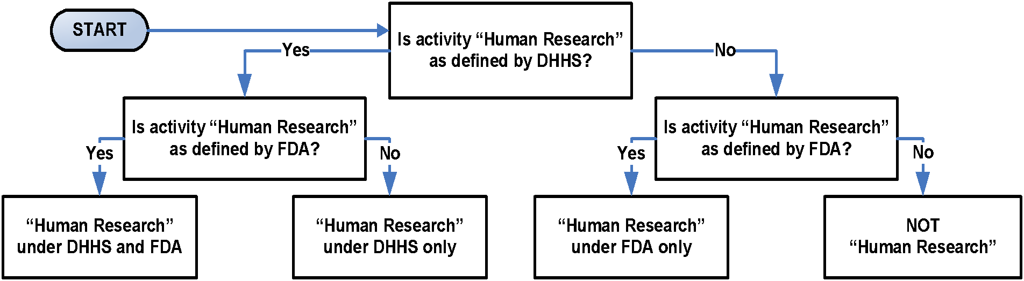
- Research as Defined by DHHS Regulations (Check if “Yes”)
☐ Is the activity an investigation? (Investigation: a searching inquiry for facts; detailed or careful examination.)
☐ Is the investigation systematic? (Systematic: having or involving a system, method, or plan.)
☐ Is the systematic investigation designed to develop or contribute to knowledge? (Designed: observable behaviors used to develop or contribute to knowledge. Develop: to form the basis for a future contribution. Contribute: to result in. Knowledge: truths, facts, information.)
☐ Is the knowledge the systematic investigation is designed to develop or contribute generalizable? (Generalizable: universally or widely applicable.)
- Human Subject Under DHHS Regulations (Check if “Yes”)
☐ Is the investigator conducting the Research gathering information or biospecimens about living individuals?
- Human Subject Under DHHS Regulations (Check if “Yes”)
☐ Will the investigator use, study, or analyze information or biospecimens obtained through either of the following mechanisms? Specify which mechanism(s) apply, if yes:
☐ Physical procedures or manipulations of those individuals or their environment for Research purposes (“Intervention”).
☐ Communication or interpersonal contact with the individuals. ("Interaction”).
- Human Subject Under DHHS Regulations (Check if “Yes”)
☐ Will the investigator gather data that is either? Specify which category(s) apply if yes:
☐ The data are about behavior that occurs in a context in which an individual can reasonably expect that no observation or recording is taking place (i.e. “Private information”).
☐ Individuals have provided the data for specific purposes in which the individuals can reasonably expect that it will NOT be made public, such as a medical record (i.e. “Private information”).
☐ Can the individuals’ identities be readily ascertained or associated with the information by the investigator (i.e. “Identifiable Private Information”)?
☐ Can the individuals’ identities be readily ascertained or associated with the biospecimens (i.e., “Identifiable Biospecimen”)?
If all items are checked under 1, 2, and 3 or 1, 2, and 4, the activity is Human Research under DHHS regulations.
- Human Research Under DHHS Regulations (Check if “Yes”)
☐ Has a department or agency head, covered by the Common Rule, retained final judgment (consistent with the ethical principles of the Belmont Report) that the activity is Human Research under DHHS regulations?
If checked, the activity is Human Research under DHHS regulations.
- Human Research Under FDA Regulations (Check if “Yes”)
☐ Does the activity involve any of the following? (Check all that apply)
☐ In the United States: The use of a drug in one or more persons other than use of an approved drug in the course of medical practice .
☐ In the United States: The use of a device in one or more persons that evaluates the safety or effectiveness of that device.
☐ Data regarding subjects or control subjects submitted to or held for inspection by FDA .
☐ Data regarding the use of a device on human specimens (identified or unidentified) submitted to or held for inspection by FDA .
If “Yes”, the activity is Human Research under FDA regulations.
- Human Research under Organizational Policy
If the activity is Human Research under DHHS regulations or under FDA regulations, it is Human Research under organizational policy.
- Engagement (Complete if the activity is Human Research. (Check if “Yes”)
☐ The organization is engaged in Human Research. Use HRP-311 - WORKSHEET - Engagement Determination.
- Comments
Comments:Click or tap here to enter text.

This document satisfies AAHRPP elements I.1.A, III.1.A
The following activities conducted or supported by the Department of Defense (DOD) are NOT research involving human subjects: Activities carried out solely for purposes of diagnosis, treatment, or prevention of injury and disease in Service members and other mission essential personnel under force health protection programs of the Department of Defense, including health surveillance pursuant to section 1074f of Reference (g) and the use of medical products consistent with DoD Instruction 6200.02. Authorized health and medical activities as part of the reasonable practice of medicine or other health professions undertaken for the sole purpose of patient treatment. Activities performed for the sole purpose of medical quality assurance consistent with 10 USC 1102 and DoDD 6025.13. Activities performed solely for an OT&E project where the activities and project meet the definition of OT&E as defined in 10 USC 139(a)(2)(A). Activities performed solely for assessing compliance of individuals and organizations with requirements applicable to military, civilian, or contractor personnel or to organizational units, including such activities as occupational drug testing, occupational health and safety reviews, network monitoring, and monitoring for compliance with requirements for protection of classified information. Activities, including program evaluation, customer satisfaction surveys, user surveys, outcome reviews, and other methods, designed solely to assess the performance of DoD programs where the results of the evaluation are only for the use of Government officials responsible for the operation or oversight of the program being evaluated and are not intended for generalized use beyond such program. Survey, interview, or surveillance activities and related analyses performed solely for authorized foreign intelligence collection purposes, as authorized by DoDD 5240.01.
The term ‘‘drug’’ means: - articles recognized in the official United States Pharmacopoeia, official Homoeopathic Pharmacopoeia of the United States, or official National Formulary, or any supplement to any of them; and - articles intended for use in the diagnosis, cure, mitigation, treatment, or prevention of disease in man or other animals; and - articles (other than food and dietary supplements) intended to affect the structure or any function of the body of man or other animals; and - articles intended for use as a component of any article specified in clause (A), (B), or (C).
“Other than the use of an approved drug in the course of medical practice” refers to a practitioner providing an approved drug to a patient because the practitioner believes the drug to be in the best interests of the patient. If the protocol specifies the use of the drug, it is not in the course of medical practice unless use of the drug is completely up to the discretion of the practitioner.
The term ‘‘device’’ means an instrument, apparatus, implement, machine, contrivance, implant, in vitro reagent, or other similar or related article, including any component, part, or accessory, which is: - recognized in the official National Formulary, or the United States Pharmacopeia, or any supplement to them, - intended for use in the diagnosis of disease or other conditions, or in the cure, mitigation, treatment, or prevention of disease, in man or other animals, or intended to affect the structure or any function of the body of man or other animals, and which does not achieve its primary intended purposes through chemical action within or on the body of man or other animals and which is not dependent upon being metabolized for the achievement of its primary intended purposes.
This is specific to submissions that are part of an application for a research or marketing permit. However, unless otherwise indicated, assume all submissions to FDA meet this requirement.
This is specific to submissions that are part of an application for a research or marketing permit. However, unless otherwise indicated, assume all submissions to FDA meet this requirement.

